**Logo%20Main%20200**

**Boston University**

**Electrical & Computer Engineering**

**EC464 Capstone Senior Design Project**

User's Manual

DOSeye Probe

Submitted to



Professor Roblyer

Raeef Istfan

[roblyer@bu.edu](mailto:roblyer@bu.edu)

[raeef@bu.edu](mailto:raeef@bu.edu)

by

Team 3

Team DOSeye

Team Members

Alex Wang [amwang@bu.edu](mailto:amwang@bu.edu)

Ami Vyas [amivyas@bu.edu](mailto:amivyas@bu.edu)

Mike Ethier [methier@bu.edu](mailto:methier@bu.edu)

Solomon Utain [sutain@bu.edu](mailto:sutain@bu.edu)

Submitted: 04/07/17

#### DOSeye Probe

#### Table of Contents

Executive Summary ii

1 Introduction 1

2 System Overview and Installation 2

2.1 Overview block diagram 2

2.2 User interface. 2

2.3 Physical description. 4

2.4 Installation, setup, and support 9

3 Operation of the Project 11

3.1 Operating Mode 1: Normal Operation 11

3.2 Operating Mode 2: Abnormal Operations 11

3.3 Safety Issues 12

4 Technical Background 13

5 Cost Breakdown 14

6 Appendices 15

6.1 Appendix A - Specifications 16

6.2 Appendix B – Team Information 16

6.3 Appendix C - Component Datasheets……………………………………………………………17

# Executive Summary

The DOSeye is an enclosed module with the capability to measure hemodynamic changes within human tissue. The measurements are taken by a laser light source and sensitive photodetector contained within our module which, when combined with diffuse optical spectroscopy technology, can be used to calculate the optical properties of a piece of tissue. The associated file tagging system can use information in the data to automatically organize the files into a searchable and user-friendly database. The DOSeye will be used as a stepping stone to eventually create a smaller probe using the same electronic components that can be used to measure the changes of a tumor during chemotherapy. Using the probe, patients and doctors will have faster feedback on the efficacy of their chemotherapy sessions.

# Introduction

Diffuse Optical Spectroscopic Imaging technology can be used to measure the optical properties of a substance. The Biomedical Optics Lab at Boston University uses this technology to measure metabolic changes in breast tissue to evaluate the effectiveness of chemotherapy treatments. These results can be produced much faster than those created by conventional MRI technology - saving the patient from undergoing unnecessary treatment and allowing doctors to adjust the therapy course accordingly.

DOSI technology requires a light source which modulates the intensity of light at a range of frequencies and directs it into tissue which contains a tumor. A detector which can measure the phase shift and change in intensity of the light is placed at a point a certain distance away from the light source and the signals are amplified and analyzed. The analysis will produce scattering and absorption coefficients of the tissue being measured, which gives the user insight into its composition. The data is saved into .asc files, which are currently organized by a conventional Windows file structure.

The purpose of this project is to create an optimized single optode finger probe which uses a vertical cavity surface emitting laser (VCSEL) as a source and an avalanche photodiode (APD) as the detector. This single optode, when paired with DOSI technology, is used to detect the hemodynamics within a finger. This probe in its base form will be used by our customer as a stepping stone for a future breast cancer monitor which will have a multi-optode configuration. It will be a small, comfortable, wearable device which can take constant measurements throughout the chemotherapy session without the assistance of a medical professional. The project also includes a tagging database which will be able to associate tags to the files and search for specific file features - making organization and search much easier for the user.

The following sections will describe the technical features of the product, along with instructions for use. A system overview and installation details with expected outputs will also be detailed. A cost breakdown is included for a future probe, if the customer should choose to continue along this path.

# System Overview and Installation

## Overview block diagram

## 

## Figure 1: System Block Diagram

## User interface.

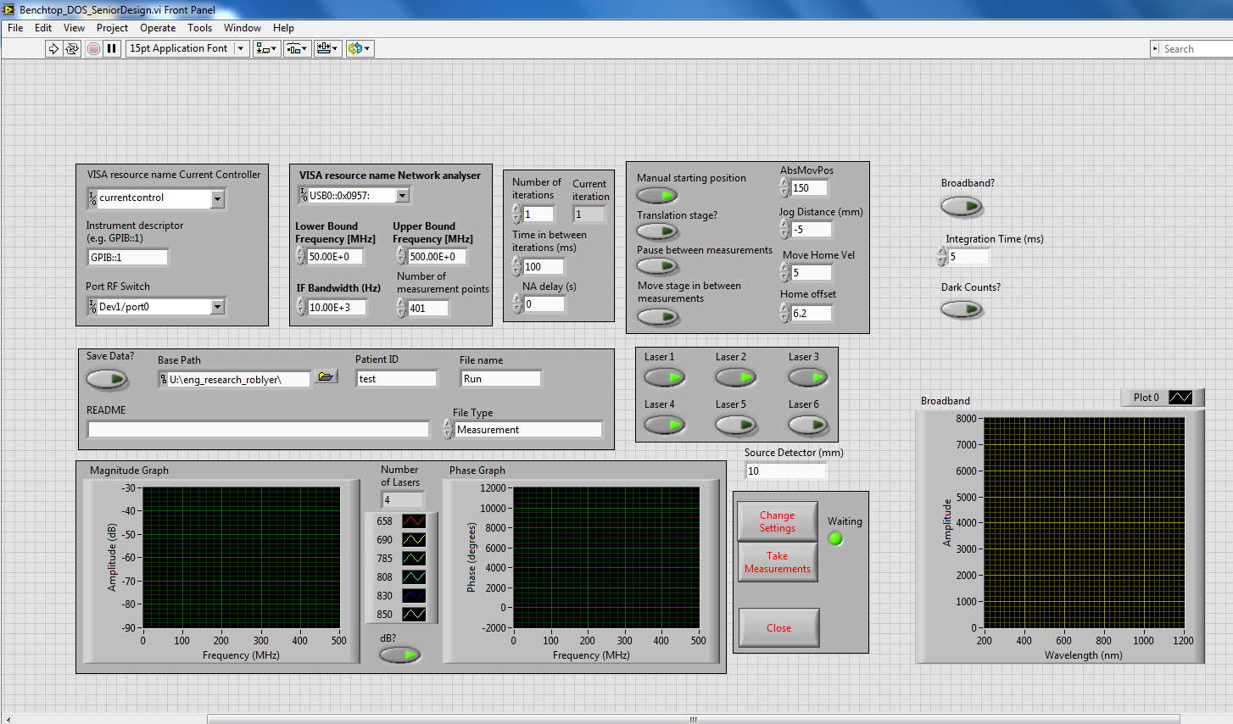

Figure 2: LabView GUI

The figure above shows the Labview GUI which was provided by the customer. In order to run the program hit the play button in the top left. The laser wavelengths can be selected by turning on lasers 1 through 4 in the GUI. The current settings can be adjusted by selecting the Change Settings button. The current defaults are optimized for the probe using a 4 wavelength VCSEL. The Run button starts the measurements. Only click this once.

## Physical description.

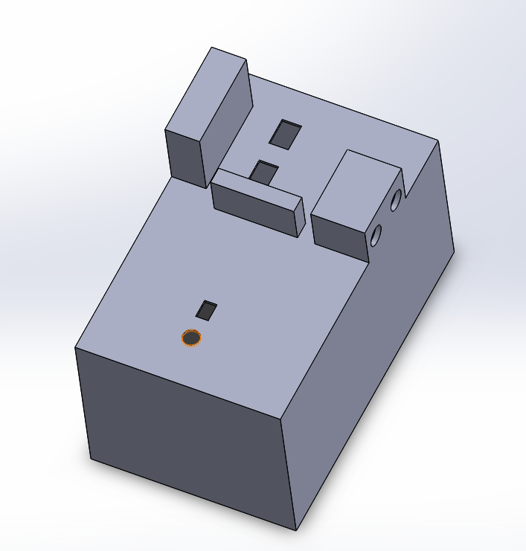

Figure 3: Probe Housing

The picture above is a screenshot of the probe in Solidworks. All three of the PCBs will be contained within this housing. The VCSEL will stick out of the hole near the edge. The APD will be stick through the rectangular hole near the VCSEL. Both will be mounted to the top of the housing. The voltage converter will be mounted to the bottom of the housing. The holes on the

furthest side are for the switches so the settings can be changed without opening the housing. There are holes for the two output ports from the APD. There’s four holes in the back for each of the VCSEL RF inputs and there’s a hole for the voltage input from the wall adapter.

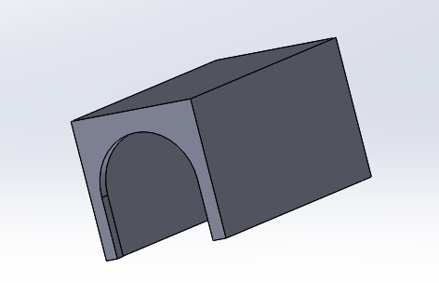

Figure 4: Finger Shielding

This is the shielding which will sit atop the probe so light from the VCSEL will not be directed towards anyone’s eyes. This will cover the APD and VCSEL when the probe is being used on a finger.

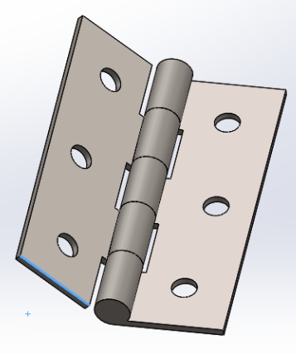

Figure 5: Hinge

This is the hinge which will attach the shielding to the housing. This way the shielding can be moved out of the way for when testing on phantoms is being done.

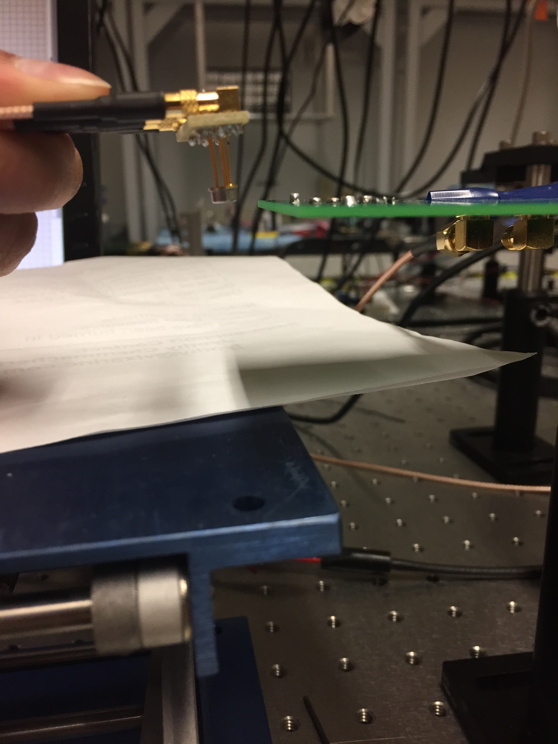

Figure 6: Inside the housing - ADP and VCSEL. Both are flush with the surface of the housing.

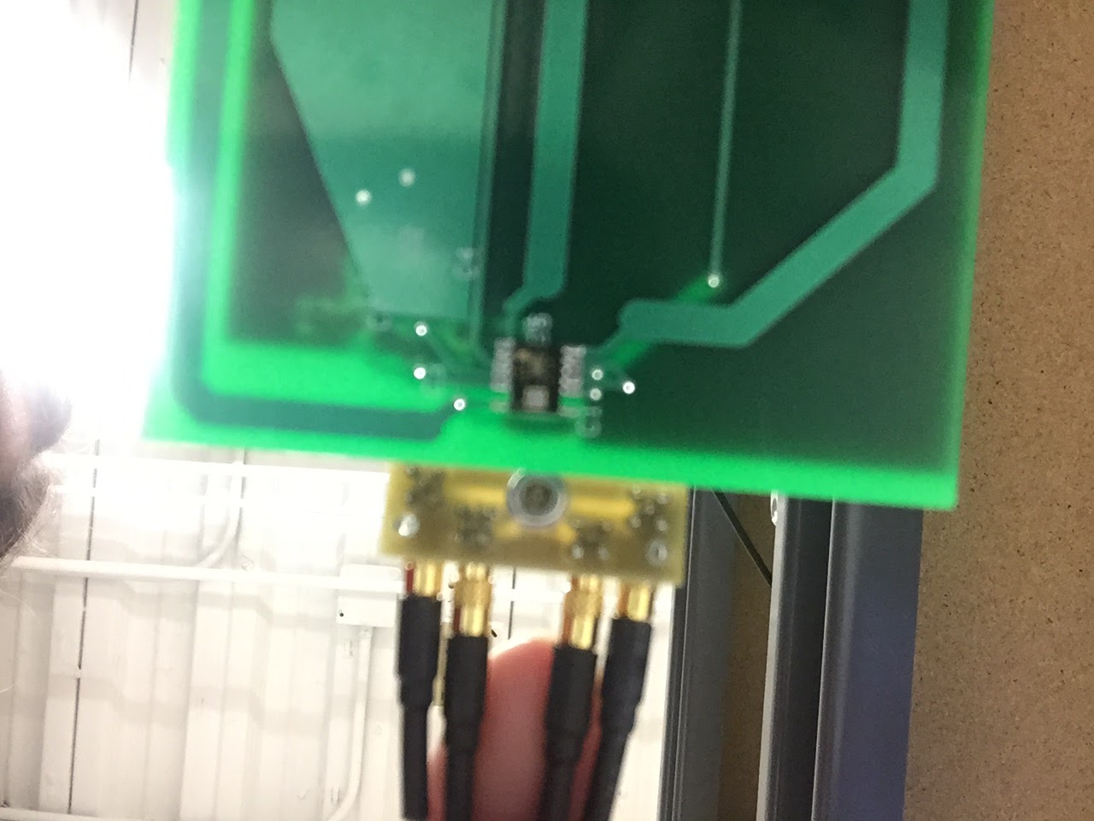Figure 7: Bottom view

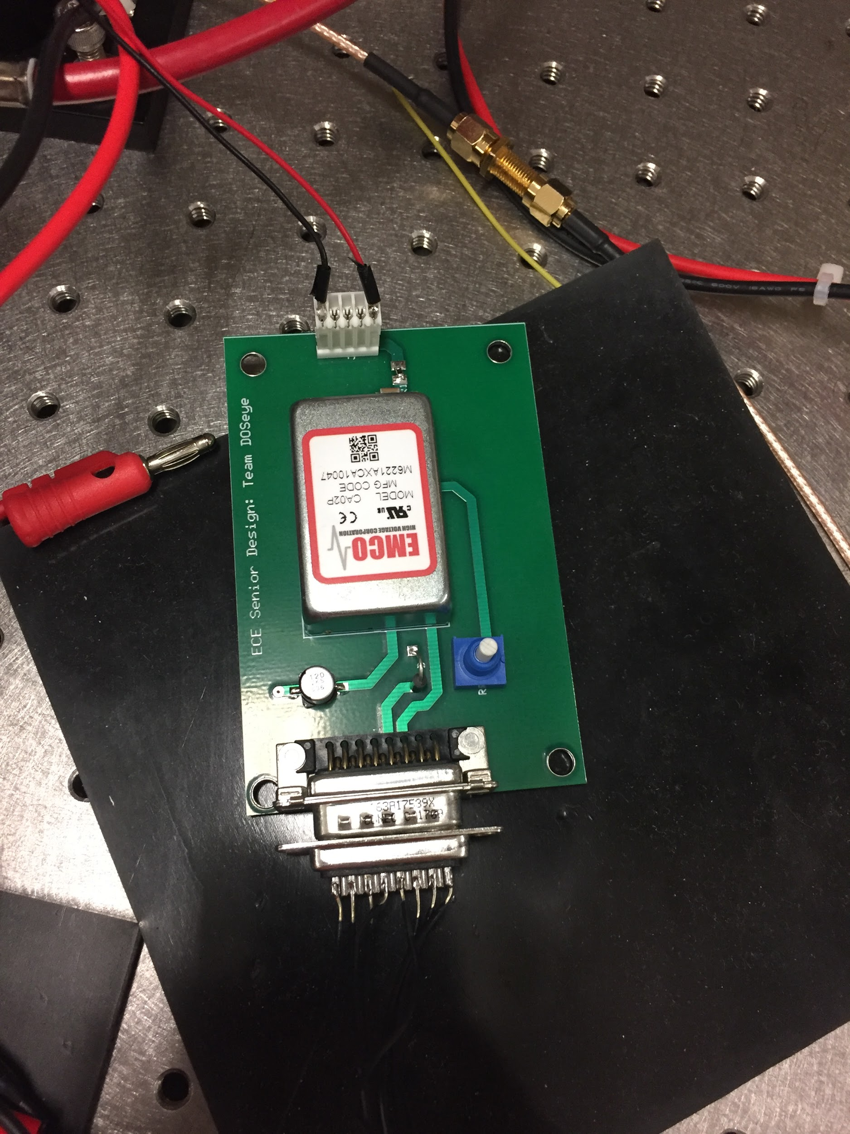

Figure 8: High voltage PCB - also inside the housing

## Installation, setup, and support

*Testing Setup*

To take a measurement using the probe, first connect the current controller to the biased T and then connect the biased T to both the VCSEL PCB and the RF switch. Make all of these connections using RF connectors. Do this for all 4 wavelengths. Supply 5 V DC to the RF switch using the power supply. Plug in the USB coming from the current controller into the computer and run the computer in 32-bit mode for LabView control of components. Connect SMA1 which is output 1 for the evaluation board to Port 2 on the network analyzer using an RF connector. For testing the APD using the high gain (differential output) setting, connect both SMA1 and SMA2 which are outputs 1 and 2 of the APD PCB into a balun. Then connect the output of the balun into the output port on the network analyzer. Plug in the AC adapter coming out of the housing into a wall outlet.

*LabView Setup*

Once the hardware is fully connected, open the LabView code by going to Benchtop DOS system -> Benchtop_DOS -> Benchtop_DOS_SeniorDesign. In the LabView code, the default settings for current values should be set to 10mA, 5mA, 15mA, and 10mA for lasers 1, 3, 3, and 4 respectively. The power level for all four lasers should be set to 6dB. The wavelength values should be 660nm, 680nm, 775nm, and 795nm for lasers 1-4 respectively. Make sure to enter a source-detector separation of 10mm. Click “run” by using the white arrow in the top left corner. Then make sure to name your file and turn “Save Data” on along with Lasers 1-4. Finally, press “Take Measurements” on the LabView GUI to take a measurement. The data will be output into a .asc file which can be opened with Excel, notepad, or MATLAB. To process the data to obtain scattering and absorption coefficients, run the customer’s MATLAB code.

*Initial Hardware Setup: Inside the box*

The APD board switches should be in the Low Gain, DCFB on configuration within the box. The output from the high voltage converter should be connected to the high voltage input on the APD PCB. The 3.3V converter should be connected to the low voltage input. Referring to the diagram below for the high voltage converter PCB, input pin 5 should be connected to the 12V DC output from the AC to DC converter. Input Pins 4 and 7 should be connected to the output of the 5V DC to DC converter. Input Pins 3, 6, and 8 should all be connected together, while Input Pins 1 and 2 should be grounded. Additionally, the inputs for both the 3.3V DC to DC converter and the 5 V DC to DC converter should be connected to the 12V output of the AC to DC converter. Finally, the output of the 3.3V DC to DC converter should be connected to the low voltage input of the APD PCB. In order to change the high voltage input into the APD PCB, adjust the potentiometer on the high voltage PCB. In order to change the gain or background correction settings, use the switches on the APD PCB.

*Software Setup*

Initial setup of the software system requires multiple dependencies. The system’s compatibility across operating systems is limited by this system’s semantic file system, TMSU. As of writing, the most current version of TMSU has binary builds for only i686 and x86_64 processor architectures, and is only supported on GNU operating systems.

To retrieve a release appropriate to the host system, download from <github.com/oniony/TMSU/releases>. Once downloaded, install the following necessary packages, all obtainable through the CLI “sudo apt-get install” command or equivalent: Python, FUSE, Sqlite3. Python is required for interfacing with TMSU, FUSE is required for the virtual filesystem, and Sqlite 3 is required for the database. Next install the binary. For most operating systems this can be done with the command “sudo cp bin/tmsu /usr/bin”. Copy all provided scripts and executables to a known directory. Database creation is handled automatically by the tag propagation script on its first run. The final step is to mount the research drive to the host file system using the credentials of any user account with access to the Roblyer lab’s folder. This can be done by adding a network location with the host filesystem.

# Operation of the Project

*[This section describes how to use the project. Anticipate what the User needs to know and do Set-up and configuration were discussed in Section 2 already.]*

## Operating Mode 1: Normal Operation

The APD PCB can be used in four different modes. There’s two switches, one which switches from low gain to high gain and another which switches from DCFB off to DCFB on. Low gain has a gain of x1 and high gain has a gain of x20. DCFB is used as background correction as it turns on a direct current feedback loop. When the switch is in low gain mode, an RF connector should be attached to SMA1 on the APD PCB which corresponds to output one. If the high gain setting is on, then the output from the APD is differential so RF connectors should be used on both output ports SMA1 and SMA2 respectively. Connect both of these to a balun and connect the output of the balun into the output port on the network analyzer.

On the voltage converter PCB there is a potentiometer, this can be adjusting in order to change the high voltage input of the APD. Using a flathead screwdriver turn the potentiometer right to increase the voltage and turn it left to decrease the voltage.

In normal operating mode, the probe is connected to the network analyzer via an RF cable. The network analyzer reads the raw data and sends it to the computer running the labview GUI which saves the data as a .asc file.

Data files are then transferred to the Roblyer lab’s folder within BU Engineering’s research drive. A user can access the machine hosting the software system that manages the file tag database. Running the provided executable runs a script that updates the database with tags from files not already present in the database.

A user can run search queries for files that meet certain criteria or ranges of criteria. On the software system host machine, running the provided executable opens a user interface where a user can select tags present in the database and specify desired or undesired values as search parameters. The user has the option to select how to display query results: as a list of filenames, as a folder containing links to the files, or as a folder containing copies of the files. (This functionality is not yet implemented.)

## Operating Mode 2: Abnormal Operations

When attempting to run the LabView Code, if it does not run properly meaning that the laser never turns on, first, check that the USB from the current controller is plugged into the computer. If that doesn’t work, then close the program and reopen it. If neither of the above work, then the computer is operating in 64-bit mode which is the cause of the error. Restart the computer and when it is turning back on be sure to run 32-bit mode.

When running the code to use the probe, make sure that the current controller beeps as this is a vocal queue which tells that the current controller is connected. If the current controller has an error, it will display an error code starting with an E. When this occurs check that all of the RF cables and biased Ts have good connections. Also check that everything is connected correctly as described in the setup section.

When operating the software system, if it does not update when new files are added to the lab folder or if scripts are unable to to communicate with the database, ensure the host machine is on and networked, and ensure the research drive is mounted. In the case that the system is unresponsive, attempt a system restart. In the case the system remains nonfunctional, attempt a complete reinstall of the host system. Note that you can either back up the database located in the “.tmsu” folder in the root directory of the lab folder, or propagate the database after installation. No data files will be lost as a result of the installation, as the database only stores information about the data files, not the files themselves.

## Safety Issues

Do not look directly at the laser. When using the probe on fingers or when it is just stationery, be sure to cover the laser and your finger with the shielding. This is a 4 mW so exposure isn’t harmful but direct light can cause eye injuries.

If for some reason the PCBs are outside of the housing, use caution when using the probe because there is a high voltage input into the APD. Be aware of where the high voltage connections are and do not touch them when the probe is plugged as this voltage goes up to 200 Volts which is a lethal amount.

# Technical Background

Our probe uses a Vertical Cavity Surface Emitting Laser (VCSEL) as it’s light source and an Avalanche Photodiode (APD) as it’s detector. These components were specially chosen for this particular instrument due to their properties. The custom-made VCSEL has the ability to output at the four different wavelengths that the four main components of breast tissue respond best to, making for more thorough measurements. The APD detects best at the range of wavelengths being output by the VCSEL. This particular device also contains a transimpedance amplifier built into the IC which immediately elevates the signal without introducing much noise into the setup.

Our module includes in-unit voltage conversion to provide both a 3.3V and variable ~170V DC input to the board using wall power. This makes the probe less cumbersome to use and moves it a step closer to being a small monitor for breast cancer by making it independent of large, expensive external power supplies. The voltage of 170V was chosen over higher voltages as the signals measured by the APD were saturated at higher input voltages.

Our Printed Circuit Board for our APD uses impedance matching on the traces to reduce noise. The traces for the SMA outputs are about 120 mils wide, so the traces have a characteristic impedance of approximately 50 ohms. This matches the impedance of the SMA connectors, which are also 50 ohms. The filters are also located as close as possible to the APD to avoid introducing more noise to the system. The APD itself is located a close to the edge of the board as possible to allow the possibility of shorter source-detector separations.

All data files recorded by the DOSI system are .asc files. They are organized in a header/body format, with metadata in the header and raw data in the body. These files all follow a predictable format in their metadata. For example, most tag/value combinations exist one per line with a colon and a space separating the tag from the value. There are special cases as well, but these too are of known format. To organize files and make them searchable by arbitrary parameters, the software system parses through each file’s metadata to generate tags and tag values to apply to the file. This descriptive data about the file is added to the database.

The core of the software system is its database. Functionally, it stores information about all non-raw (i.e. containing a header) .asc data files within the lab’s folder. It stores filename, file location relative to the database’s root directory, tags, and tag values. This information is useful for conducting search queries when looking for files that meet certain parameters in details regarding their data acquisition.

# Cost Breakdown

Consider your EC464 prototype to be the *alpha* version. The next unit made, according to your engineering specifications and design, would be the *beta* version. Later a manufacturing version or release-version would be made.

What would be the cost of your ***beta*** unit when it is created? This should assume market costs, i.e. no donations, no picking through the customer’s parts closet.

You can edit the table below to describe the project expenses for the beta version. It is not necessary to provide every detail about parts, labor, and services in your cost breakdown. Decide upon a level of aggregation of investment and group costs accordingly.

|  |  |  |  |  |
| --- | --- | --- | --- | --- |
| Project Costs for Production of Beta Version (Next Unit after Prototype) | | | | |
| Item | Quantity | Description | Unit Cost | Extended Cost |
| 1 | 3 | VCSEL PCB |  | $70.93 |
| 2 |  | Voltage Converter Parts |  | $191.15 |
| 3 | 25 | 0.1 uF Capacitors |  | $8.95 |
| 4 |  | APD Parts |  | $14.44 |
| 5 |  | APD Switches |  | $11.74 |
| 6 |  | Voltage PCB |  | $90.93 |
| 7 |  | APD PCB |  | $90.93 |
| 8 |  | High Voltage Converter |  | $202.00 |
| Beta Version-Total Cost | | | | $681.07 |

# Appendices

*[Appendices include supplemental information for the User that would distract if included in the regular sections.*

## Appendix A - Specifications

|  |  |
| --- | --- |
| **Table 2: Specifications** | |
| **Feature** | **Specification** |
| ***Housing*** | |
| Size | 128 mm x 78 mm x 90 mm |
| Source-Detector Separation | 10 mm |
| ***High Voltage Converter*** | |
| Input Voltage | 120 V AC |
| Output Voltages | 3.3 V DC, 150-210 V DC (variable) |
| ***APD Board*** | |
| Average Operating Voltage - APD | 170 V DC |
| Max Voltage - APD | 200 V DC |
| Average Current - APD | 0.4 mA |
| Operating Voltage - Board | 3.3 V DC |
| Current - Board | 240 mA |
| ***VCSEL Board*** | |
| Current | Laser 1 (660nm) - 10 mA |
| Laser 2 (680nm) - 5 mA |
| Laser 3 (775nm) - 15 mA |
| Laser 4 (795nm) - 10 mA |
| Power | 6 dB for all lasers |
| ***Probe*** | |
| Average Drift over 1 hour | 2% |
| Average Accuracy | 55% error |
| ***Useable Bandwidth (SNR > 20dB)*** | 50 - 450 MHz |

## Appendix B – Team Information

***Alex Wang***

Alex Wang is an Electrical Engineering and Biomedical Engineering double major at Boston University. He is planning on enrolling in Boston University’s M-eng program.

***Mike Ethier***

Mike Ethier is a student in Electrical Engineering and has a minor in Mechanical Engineering. He has also taken several computer engineering classes. He is Professor Pisano’s favorite Teaching Assistant for EC402 Control Systems. He is currently still deciding on where he will be working in the future.

***Ami Vyas***

Ami Vyas is an Electrical Engineering major with a concentration in Energy Technologies.

***Solomon Utain***

Solomon Utain is a Computer Engineering major with a minor in Biomedical Engineering.

## Appendix C – Component Datasheets

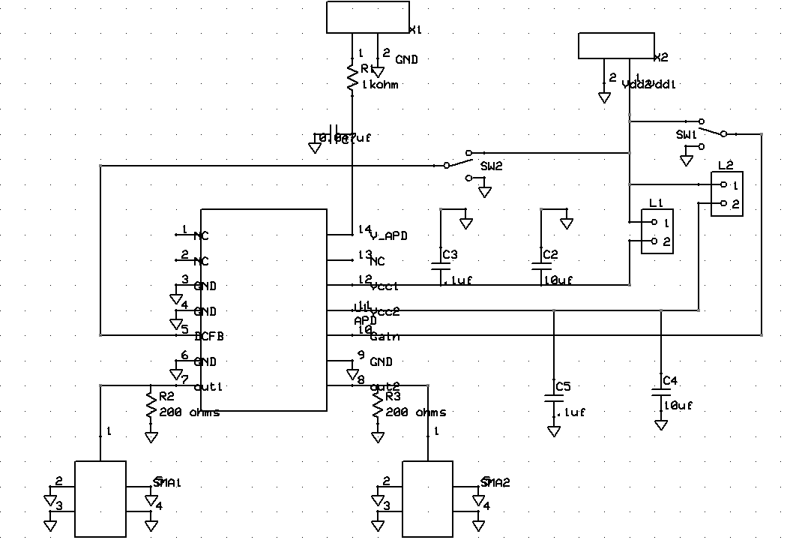

APD PCB Schematic

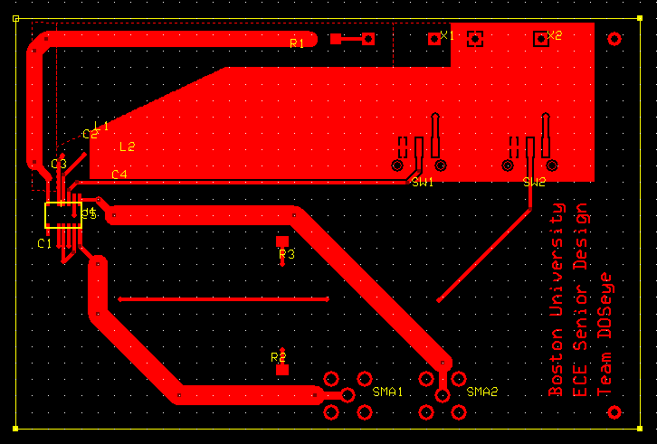

APD PCB Design (Top Layer)

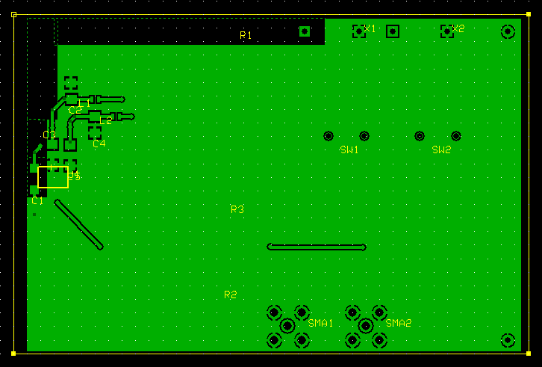

APD PCB Design (Bottom Layer)

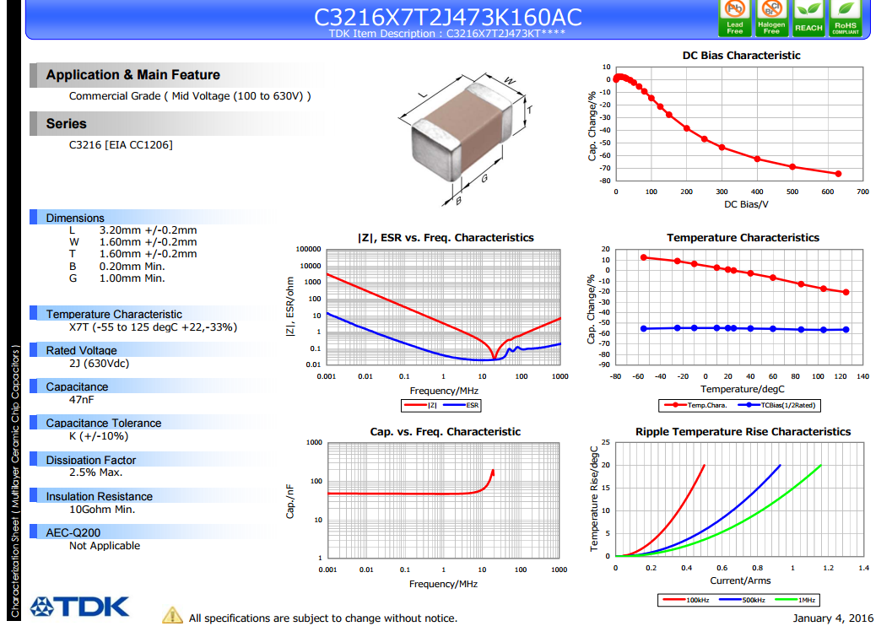

Datasheet for 0.047 uF Capacitor

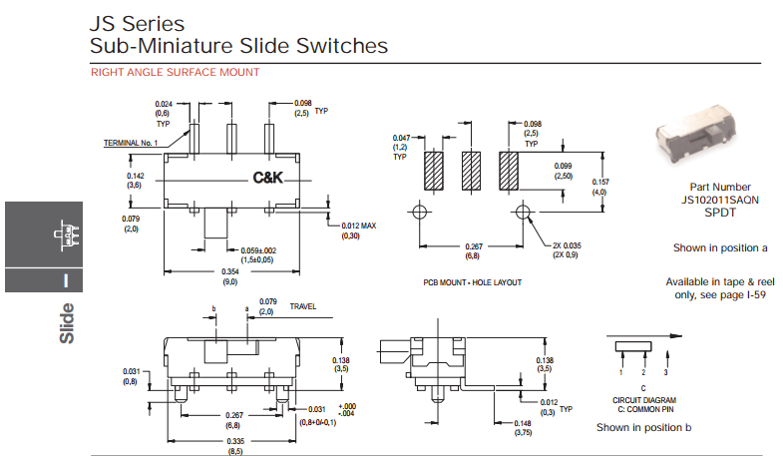

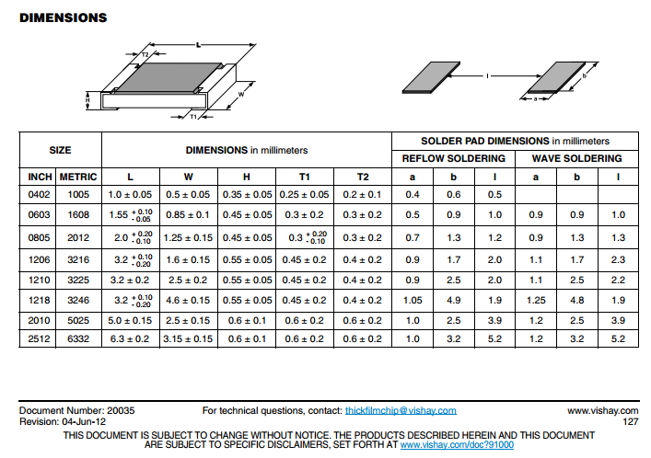

Dimensions for 200 ohm resistors (used 1206 size, digikey #541-200ECT-ND)

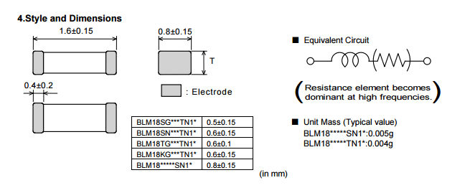

Dimensions for BLM18PG221SN1D Ferrite Bead

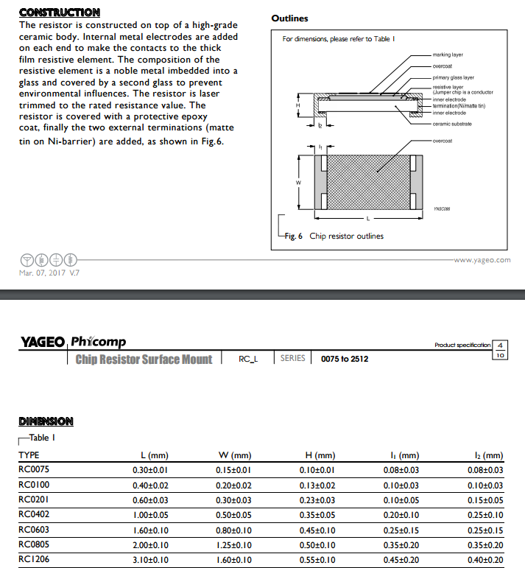

Outline and dimensions for 1kOhm Resistor, used size 1206, digikey #311-1.00KFRCT-ND

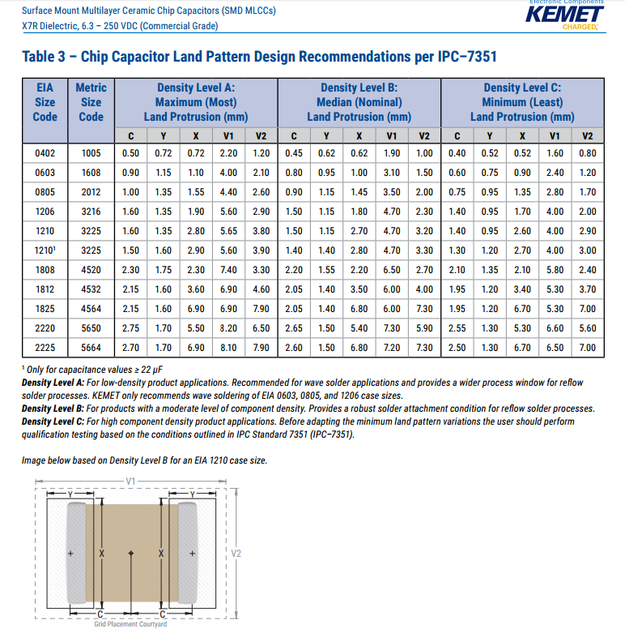

Datasheet and PCB Pad dimensions for 0.1 uF capacitor (used the 1206 size))

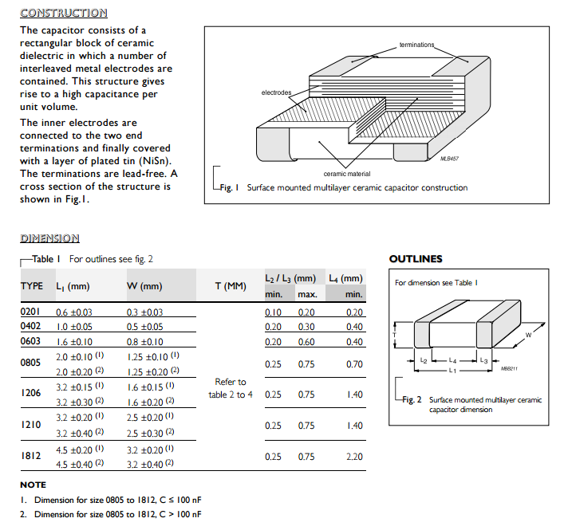

Datasheet for 10uF capacitor, used 1206 size, digikey #311-1376-1-ND

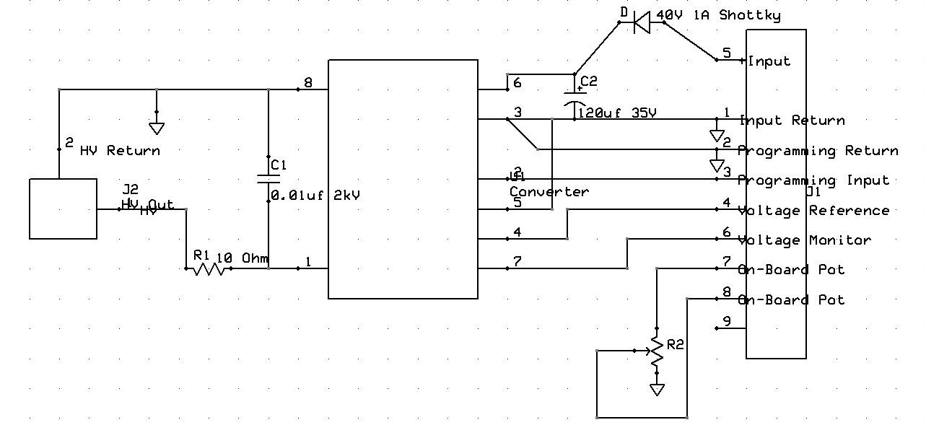

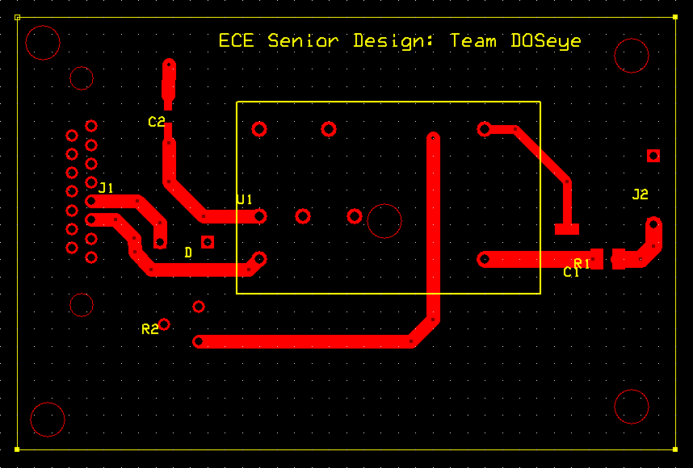



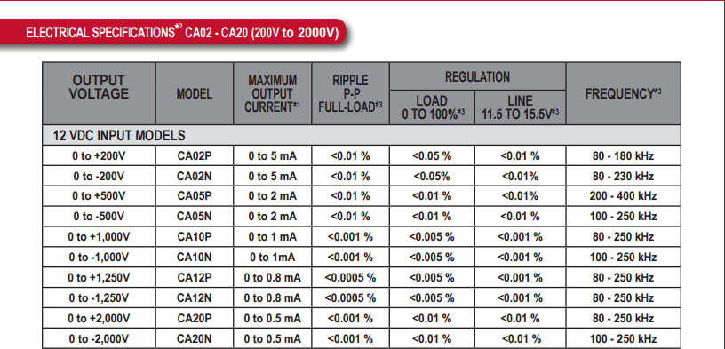

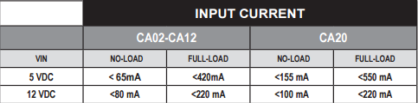

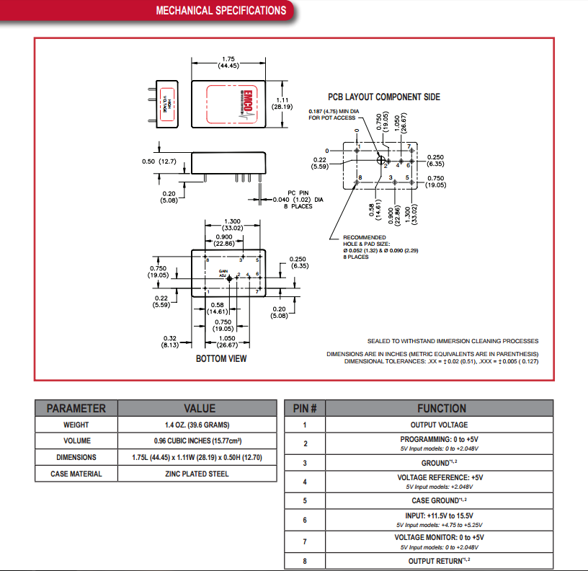

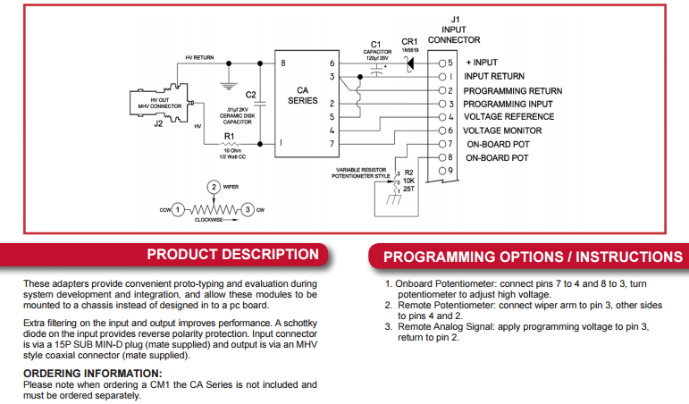

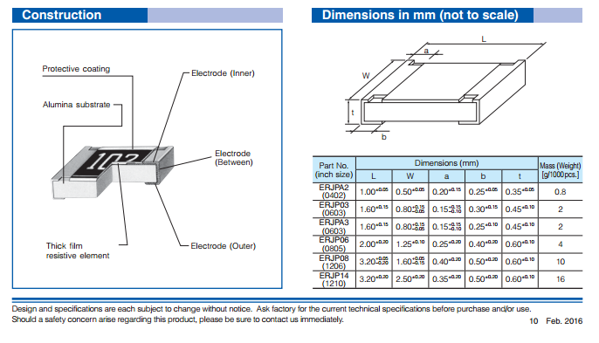

Dimensions for 10 ohm resistor (used part No. ERJP06 from table, digi-key #P16861CT-ND)

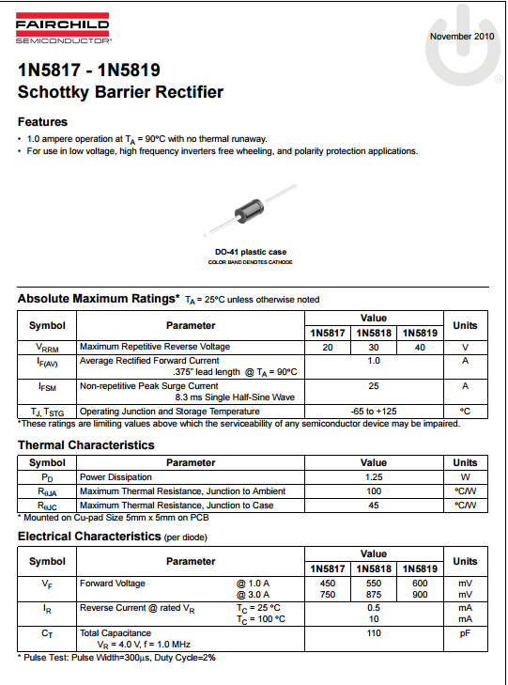

Datasheet for 1N5819 Schottky Diode

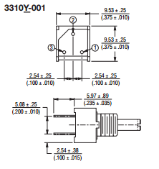

Dimensions for 1kOhm Potentiometer, digikey part #3310Y-001-103L-ND

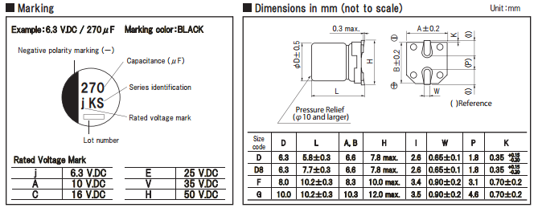

Marking and Dimensions for 120uF electrolytic capacitor, digikey #P18961CT-ND

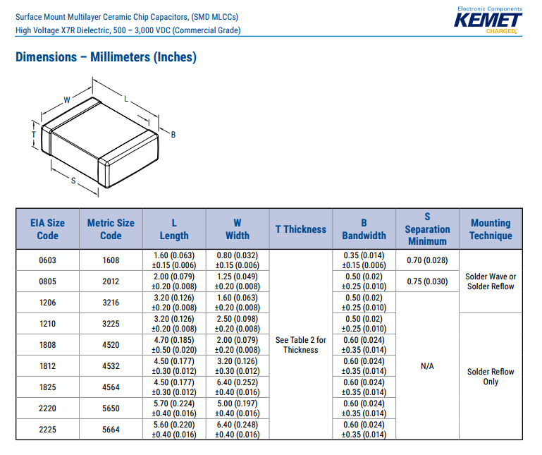

Dimensions for 10000pF capacitor, used size 1812, digikey #399-10477-1-ND

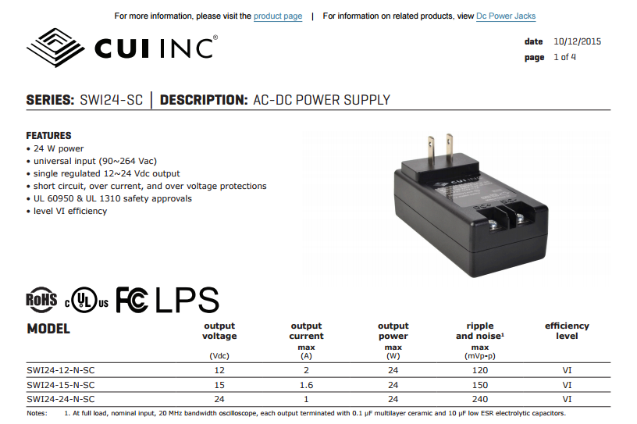

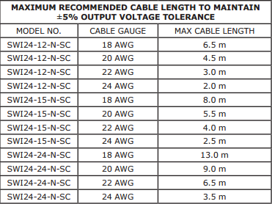



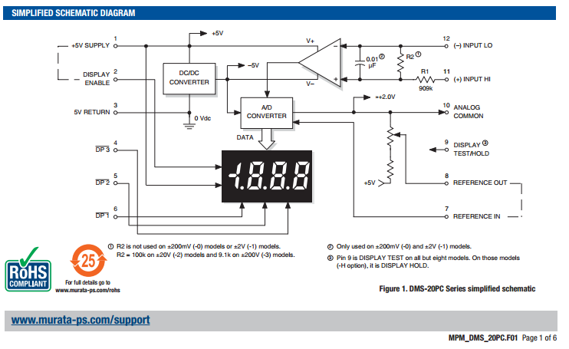

Mini Voltmeter Schematic